**TEAM MEETINGS & CONSULTATIONS WITH JEFFREY**

**CONSULTATION WITH JEFFREY**

1. 10th October

Discussion of the problem we were approaching (i.e.- marijuana)

How to deal with the mentioned topic

1. 20th October

Showing the progress our data, done with the data gathering, pre-processing and sentiment analysis and topic analysis.

1. 21st October

Showing the progress of our teamwork.

Getting insights of how to deal with the graph problem.

**Team meetings**

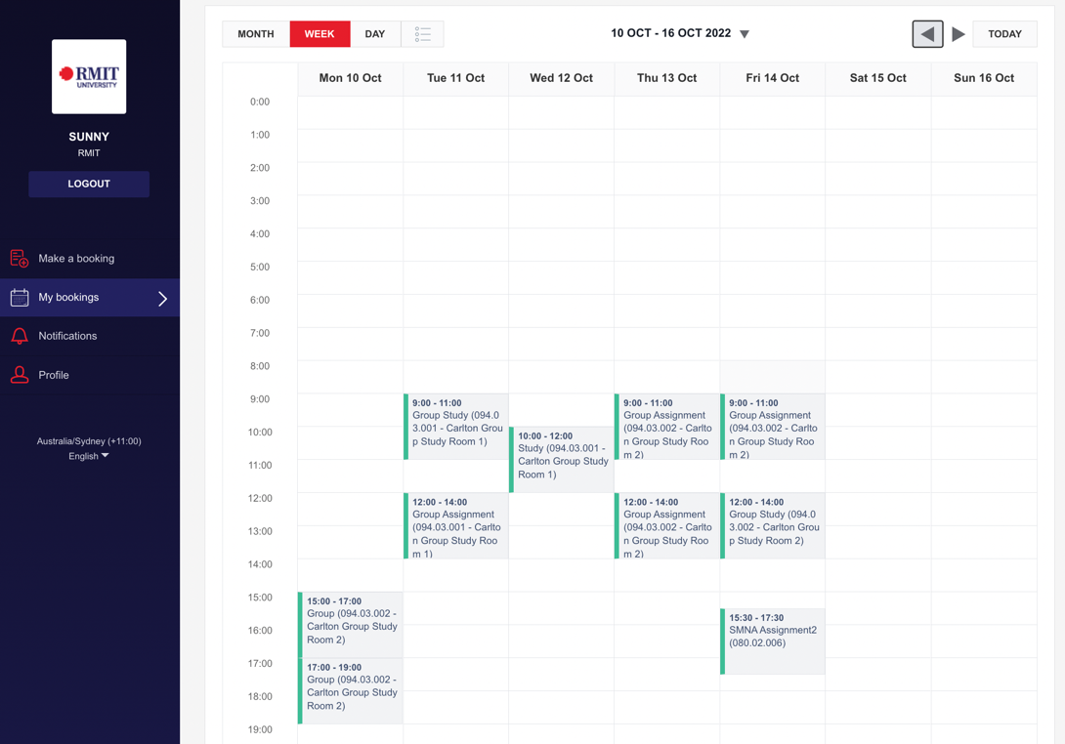

The above figures shows the day we engaged together for the assignment at the RMIT library.

Also we conducted teams meetings every Monday, Wednesday and Saturday at 8:00pm.